_{a&#arft} q-r
ffi
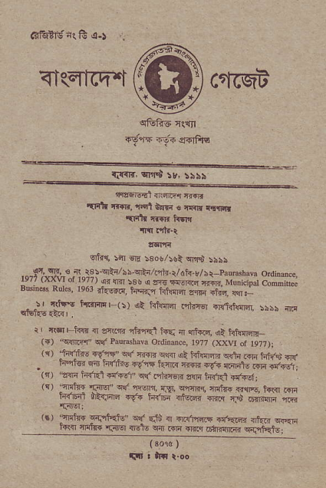
<l(Efch.t crr(qa
^{qG66} r.iB
Fd'ls F;F !6Fs
%_{tlfir,} ^{qr.r*} rv, rils
--
^{naqq{t} rna@ i@
.talr ^{!r.*,} rqt EFtr{ s ^{fir criirr ,{r{h} {..n ^{trw} ,r{.,rh,r
^{' qhi,} !'II Era _{tsoe/!$i} ^{qi$} :i\5
_{."r9t_T,} ^{€.{^>3!oir/!r rt-/(rq.:/dh} _{e/sr-} ^{prm\bNr} odinue, ' sB EEr{l-q @R. Mutrc pal ^{comdF} BG !s! Rotq. ^{le6r} ?i,€Etq hry w.@ o+ .#. q. r {rtft h..rnrF, ^{s/ ,i.d!'H} e,h-Er ^{6lIt€a.} 5s,: fld
qr5l?s.E6' ,
r, {'IFi{r ri actw,ft,F{t _{hE n} ^{qt} ra, at t{r{,{,fl _{(ir)} ^{.slm{,qrf Pautuh3w} ordinmc, le7? ^{(xxtr} or 1e?7)i _{r{,} ^{.cjii'r'c.s,r' q} _{'lJq} ^{qF} ut ^{h!!@qljn} @ l*irE +r{
. r+qr.? @ nfirq _{{s,5} ^{.trR} {&R ^{6qa} a?FtE rl'F ^{{rbs1,} _{(n)} ^{.?ri} _{tsRli-l5rjlfp} ^{q(.nJre-rn} a{lr tRtl F6; _{rsr} ^{'r'tr4} _{{a!ir 5r} .,@f, trg, cmr' ira?. aft, kd .6ri F{F_ fit r}d 69_+ rirrF {tuiF {@ E5 6!l?dn nlr _{(r)} ^{'a]ninF} l{:qrfzb' ^{qr} dui
trrrr ^{filitr{} _{"r.alsl} n6lE $fi rI ir.{Pfatr rqkF{ {rt{r? crEri r{R }]r.Y _{FrrinrFi} q{.qkJ.6;
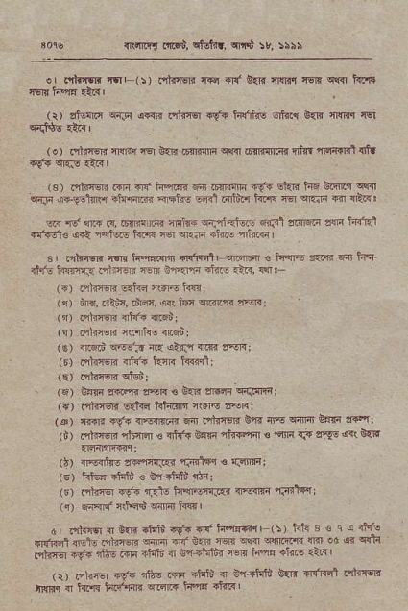
_{4t! mci, cffi!} ^{qi.i} 5v, !!s5
o, .iltlrsfl rqF(:) nlrr6R {€r +r{ so. ^{qmr} _{wm} ^{qr<r} lrct re_rilw rtrlt'
^{(ir} _{,t|m} ^{.;|]i} !@ _{rtq} 'f" h'fiN rnh €.R tr{Rr ei cd$E €E I
^{(o)} lqkr€n rEI4q _{:Er} ^{grri} _{dlriffi s{{r .rilffi!{lt n1nt} ^{'rEfdrlit} {i.
⁽³⁾ nhlM m {{ h.@ 6t o€ffiIiq 4({ shir ts6 _{Ee'l.t} qlrci ^{qr:lr} a{.a€l{tn aillrlm F ne -dil d$i.'r i.i{'r € ^{q..F} € {E&:
_{w'rd} ^{qtlr} .!, _{.n.rniri' 4!iia} ^{q"ri'rl'riq!} Ftr31 arnsri zffi iaift1 _{+'i.+dr€} ^{qri} {'fiGc i<.F _{r€r} ^{qn'F} _{ituE} ^{'mrRr} r
sr ntrrw rq{ hqrds _{n{Fnl,ffi € h'rl.G sers} -'rJ i{n_ _{.1q15 hrn'3} ^{pnirn} r.n{ i*{J'ri ift.r .lF, M:
^{(.)} rltreri E{i€ aff€ irEi
^{('1)} _{fiB, tilic, rdr4t, s<r ht} ^{qilde} sErr;
^{(r)} nhl@ d{'+ {Fd;
(!) raret{ r(erd{s {ri6n!
(!) _{c6rd} ^{q<!:r} nR dtril ff{{ sqr;
⁽⁵⁾ Flirsn {tu'? km t{{ffl;
(E) _{ohagr{} ql$n;
. (6) tsrln ffi FF € _{irE ani4} qdi{li:l;
({) nlT&-F !*.d tr@r r$r\' ?reRr
(,s) {r-r{ r9'{ rr4min{ n irhT€]{ _{EF ffi} ^{qinir} Esa" zrcq; (i) _{dihffi} ^{ql6rrEr} € rltr{ _{Bslr lliFrrrl €} ^{'cnq} _{{F} ^{g{v} €qt &r.
(l) {-irt.- _{,@rr.rqs} ^{qFilqq} € {.qrnr;
(s) htu{ rhli 6 En-4irii tla;
(E) nhTq +(+ ,Rrs h'{M{Ii3 _{{jd{{} 'rnrltYl
(q) nqar{insdlFw h{{l
d, i'dffi { ^{6rrn} _{"tuti 4" nf ti'r!-Frr} (s)tit{3€1c<l"fE
_{dfFd n't.eft'qe'lF@} ^{?ft.E} @ _{6lffi@.d} i'qda _{!+i-a} .E+ _{d& @} ah.j _{{ !-} ad. lq _{Jim} 'r@ 'A{l _{\rr t?-@ 5r.} ^{-"lE} _{r} .#d 4 1#i bER {'4ffi rnzr6r tMr { tffi laF+lnF aFR _{t+€ daF} I
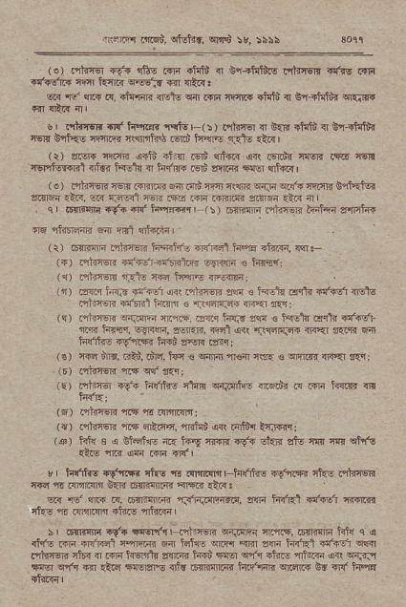
_{ni"r.q orqu>,} ^{qtuF} , ^{qr's} :r, :iii
(a) rhn.q +{{ !$E ffi dqii { Er.idils .'ftren $fis Rr4 _{r{+dK ffi i.irr} ^{q.@:a} _{1?1} qtR!
_{w} ^{qr} @ R, fi'flr irsle !|4 r{F rr5.? +i'iu> { _{6n:rtcit{} qrq]rr
$, PfirEn {l{'ts'{K nql€| (!) nhftr { ^{g:r{} _{rh$} q ^{g'{} ihlh 46lr bqkc nT6 Ji\$ntu Fr6 h\r6 rji. ctrl
(i) srsl{ '|qHr ^{qr$} 1ir{ _{65rr)} ^{qi{r q{} isr.!'{
nETrn'I{R] $L< i{Eft { hr'm Fi et!@ Ia {tr.Tl ^{(.)} .,llieTrs-F.ilriwfl Fnu!rql1c1nqiFei€qrFnSniEtu? sr{F-r.ar. @ r^E-rt ^{l@} m m tffi mF ttr 4 . ^{q} r tr{*mq -{'< iF! ii',E@, ^{(:)} ir1r6{H .,ikr€ri li4fri zrFlR
) ^{i} t6MF _{t-Fzr, tF+,} 6r? hq difE. _{e} .
", c1".8 6-., ^{!trflaF4} _{irn'} ^{r} l@.
_{a,} ^{qT@} _{ftlE} rrR e\F, +,ffi
^{(t)} .Arq ^{t} ir _{rlr4{dr} ^{q<{} hinw sF € hrtu d<rti st'r6 $Elb ."riffiEF .tffi t{{1 € f.3dr.@ {F .r f1'i
(q) .ntftrr s{im _{{1F. mr} ^{jar,!} m € tF}.r drlr +!.rdr rn Fmr, o!r4n, e1e'Rn _{erl arr} ^{r{tfil{.qF} {<<1 sqnn 6 tu'iF Fvei.a{ t{_{i ffi .?nr;
(€) Tfd u;Fr; _{ralu>, .trd. lFr €} ^{qm} fl€ri mrr: € -IIi@ <jvr r'5; (r).1lrf66mqf!.1i
(!) ^{pnlE} {fr ii(Ih$ _{c1q!} ^{q{irrms} d-atr .{ mi h{ir {t
⁽⁶⁾ Hh1ffi n { Frni{Fr;
({) ofr"JrsR nF ^{4iF4,} _{"mtuB} s!'l 6'ih t4rrw:
^{(@)} iii{ B a ffqn[6 iF feq 4€i{ .V{ shn ctu _{|1{ m} qllt ras m oq r.n {l{r
v hlrrt 6 ry"cr. ll{6 r .!.,Imr hffis rf'ffi cjiE .itrEri @n,ll'l@€4 6@-rii,s@rt r
str rc'm R. 6Tntrm f.<"rii{a:@, ffi iRff @1qvr J@Rn _{&-o} r .r'ilr{rr .i?rs aliiri
\ ir{ulJF it' _{rrornl{H'nr)@} ^{q{itFr} _{{r{.6{.nF iil{} q q +F rw _{fl{rRE't ffi fl H€} ^{qm} _{m ffi i{r'Rt.t'irdr} .@ t?iiz@ ci6{ { m lsqitd _{s!r@ ffi 38} ^{q"fr} _{fiF fltrR} qR qiFJ _{@q} ^{qr1,q} rji] *t'l _{lEofs{t 6ir:l m t4raidrn} ^{qFrr} R!.r{ hq* ^{qtrrin} I
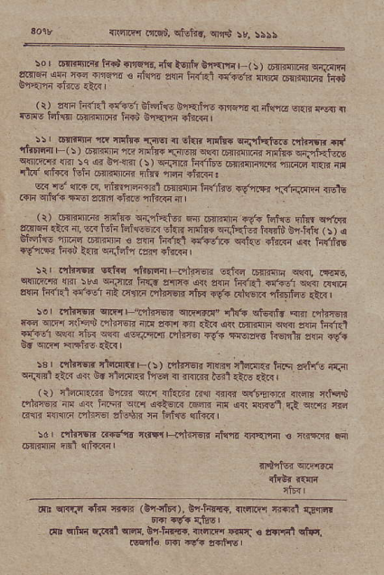
n:.i@ iinau,. srtrrr. ^{qd} :4 5515
_{_5o} ' lrlrcrj].i: t{d FfiEt' rI{ lsnfi bre}f{ r_t s I o+rqqjr.rr {rircni _{!R@} ^{rF} r-ds3 € ^{'l@} z@ _{ffi} ^{6f@R} {s.{ ^{@iqTa} t&t
^{ri)} _{-m ff} ^{d:f-64} b#ar ozalfl a*% d _{itrnu} . {d ffi c r€rft ff'r{I 6$rl[m ir{" bra6.frdl
₋ !s ffi {. T,:iF Tsrd a .is ^{miF srrid@} .n'ft; ^{{i} rr.'rrflir ^{( r} ₎ .rflrTir n _{finituF fnFrl} ^{qqr} 6{l'r"i _{nFmr} qrJiEr..E ^{sftiRr.$} s^5-o {r 9.€ _{>r} ^{ffia} "{d,ri* 6Tr.rFG{ rirrq ^{r.F,r{ '@} 4r4r< r5]l i'@iri{ _{irtfi} ^{'h} {i{@! _{w {J} ^{qftr} _{tr.} ^{qioeFr.l} @rjli l",njns .d'@ li{Er.- adb _{.*ll} ^{qrfr} 4E aFq +ift 1Il.@ { |
^{,5.(ri-.:l@':.e} _{F.?r.} ^{q .5@ rta} _{trtre iinr} q,ft zt'F ^{'i-?} {. w'st Hi-.. olrF _{mai@} ^{r"5} r i@{E Ua.ffi ^{(:,} r ^{g.ft, er@} 6r.i? €.F rnr.F,t ^{dt'} _{fta} ^{,&! rtrr !fi hrr*} rvtr{ rr{6 _{At} lr{.htu !fir +ir@ | _{:tr dir{sn} ^{q.ifi} rir'Rr,frtir@ _{E:tq.mdln} ^{q'Rr,.{N, q!ftm} _{T :r'} ^{-JJ'R l"{r} !..no e, e !i? @ri '@ F{6 _{a{ri} ^{<fl? .n 'Et} _{it} ('n ^{'drer. 'l.'{ i!r.} _{Ftlr*} ^{'ftErfa,} ,rR,
_{re, rdinsr{} ^{qrF.{r} _{".'&r€E} ^{qrFFzr"} _{lta} qtunir ^{.m} ntnm _{s€} ^{!i@} _{aiqd dliqER} ^{qo} a{l.r rn {i-{ arl _{6rr.rlrn} ^{q@} dan ^{t&€} _{ad E@} ^{-i'r} id ^{j-"iry} {'it@ rr-. ^{'em} hErn\ _{sF} 66i
5s", dhrq-nti{.rF(!) nlrrE}r onr+r rt*r.i tq.,q *r,,,n ^{r.r.o} c'+$*1 rttr a{ bc clqdR-{ h€s a nr.ira H rn6 .t.< | (r) at4r.m t-a+< ew nka; .;p.r {rR c{t.Erm n\tr' rrhq$ .'il_nlir _{il{ @t h.ii vG} ^{q<tq.r} ffi _{r]{} ^{q( qlnsl} _{r.!} ^{q\r.lr} rc al1r{ {!r{rii ilhF atu${ f{ _{ffilg} ^{qfr{} |
:d r1,@ F*Ef! *d!rF <?t<'r _{d!-? {.'{'{ c r,{-rfr} qrr
dll cnflr .trr {r.rn (Erj|k), or-hff., {R'll.rq _{ffil} q,rid Fo !f{..ts,
_{Fr} ^{qlca} _{F.r{r't} ^{qqr.} Br-hr@. Rq@ $rFr € ,ffrit cilal @6re o{ rfr r|€rhql

